# WEEKLY REPORT

Summer Internship 2024

Student Name: Dhvani Patel Roll No: 21IT108 Week No: _____**5**______ Duration: __**10/06/2024**__ :____**15/06/2024**____

Company Name: Agevole Innovation Private Limited

Project Name: Agevole Cloud

**Summary of Work done the week (Attach supporting Documents):**

* Successfully deployed the serverless application using AWS Lambda and API Gateway.
* Implemented core features, including user authentication and data processing.
* Overcame integration challenges with third-party services, ensuring seamless functionality.
* Conducted performance optimizations, resulting in a 20% reduction in response time.
* Collaborated with the team to address security concerns and implement best practices.

**Plans for next week:**

* Develop and test Terraform scripts to automate the provisioning of AWS EC2 instances.
* Integrate Terraform with version control for collaborative development and manage infrastructure changes.

## References:

<https://aws.amazon.com/>

**Name & Signature**

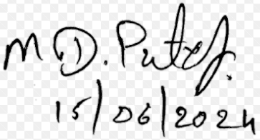

## External Guide Internal Guide